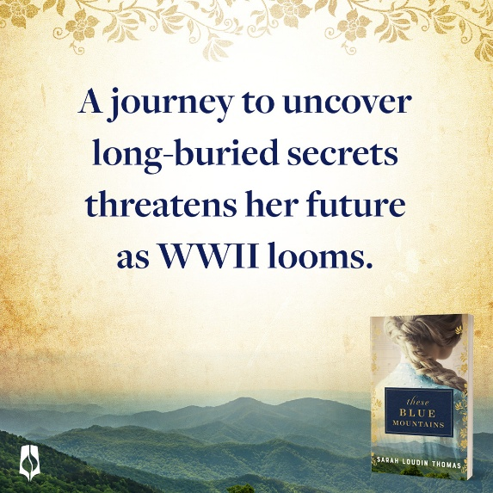
These Blue Mountains

1) What inspired the story in your book?
While researching the flood of 1916 in western North Carolina for another novel—These Tangled Threads—I came across information about a German POW camp in Hot Springs, NC. German sailors who were in US waters when war was declared were sent to North Carolina for the duration of the war. While there, they built an amazing Bavarian village almost entirely from flood debris. While digging into the history of that camp, I discovered a story about a German woman whose brother was taken prisoner and then disappeared and was presumed dead. Fifteen years later she saw his name on a cross in a photograph of a monument to German sailors who died at the camp in Hot Springs. Finally, she learned what happened to her brother. That was too astonishing a story to pass up! So, I made the brother a fiancé and sent my fictional Hedda Schlagel to America in the 1930s to try and recover the body of her long-lost love. The catch is that when they disinter Fritz’s casket . . . he’s not in it. There’s a woman’s remains there instead. Now Hedda has TWO mysteries to solve.

2) What can you tell us about the main characters in your book?
Hedda Schlagel is a pianist living in Germany who’s been mourning her lost fiancé, Fritz, for fifteen years. She’s become almost reclusive and has cut herself off from life. When she thinks she’s finally found out what happened to him, it starts a cascade of events that force her to finally move forward with her life.

Garland Jones was a guard at the POW camp where Fritz was held and is now a sheriff’s deputy in Madison County, NC. While he appears to have moved on, the night Fritz died has long haunted him. When he has an opportunity to help Hedda find closure and learn what really happened to Fritz, he steps up albeit a bit reluctantly.

Fritz Meyer, the lost fiancé, also plays a significant role in the story. He’s a brawny German sailor with a passion for art and a naturally cheerful disposition. You’ll get to me him in flashbacks.

3) Which character surprised you the most?
Fritz. Hands down. Read the story and you’ll see why.

4) Why do you think storytelling is such a powerful way to share truth?
“Tell me a story,” are some of the most compelling words in any language. As children we crave stories that surprise and delight us as well as stories that inspire us and spur us on. When we share stories, we discover the things that we have in common. Jesus knew the power of a good story and used it often!

5) What can you tell us about your next book?
My next book is also inspired by the WNC flood of 1916. Many people are familiar with Lake Toxaway, a popular resort area in the mountains. What most don’t know is that the lake sat empty for 40 years after the dam gave way following that flood. Lucy Camp Armstrong Moltz wanted to live on the lake so badly she camped on its shore for a summer to persuade her husband to build her a house there. Then, soon after the house was completed, the lake washed down the mountain. And yet, Lucy stayed and made a huge difference in many lives. I invented a character loosely based on Lucy who takes a young couple who’ve lost everything in the stock market crash of 1929 under her wing. There’s lost treasure, late-in-life romance, and underhanded dealings that land one character in prison. Coming in 2027!

6) What kind of research did you do for this book?
I always do lots of online research looking at maps, historical accounts, and just general information. A key book I used for this novel was Jaqueline Burgin Painter’s now out-of-print, The German Invasion of Western North Carolina. That book is where I found the story about a German woman finding her long-lost brother. It also includes amazing photographs of the Bavarian village. Other books that helped immensely were Black Mountain by Martin Duberman and Black Mountain College by Anne Chesky Smith and Heather South.

7) What do you want readers to take away after reading your book?
I hope this book might encourage readers to take a look at their preconceived notions about other people. I loved that while the residents of Hot Springs were initially nervous about the German sailors coming to their town, they ultimately found much to like about having them there and some even formed strong friendships. Whether people are another nationality, another faith, or simply speak with an unfamiliar accent, I think we’d do well to really get to know others before making our minds up about them.

8) What are the biggest challenges for you as an author writing historical fiction?
Time! As with many authors, I work a “day job” that means I do my writing in the evenings and on weekends. Few things feel quite so decadent as a day when all I have on my calendar is writing time. My other challenge is getting lost in research. I enjoy digging into history and the events surrounding my stories. It’s easy to find myself so caught up in research that I’m not doing as much writing as I should.

